Illinois Institute of Technology Markiyan Varhola

CHEM-124-L07 LAB CWID: 20324717

September 19, 2014

Measurements and Density

**Objective:**

The purpose of this experiment was to measure and determine the density of a metal bar and a salt solution using a variety of methods, and then to determine the error and deviation of the measurements.

**Procedure:**

A dry 50ml beaker was measured after zeroing the balance and the mass was recorded. Afterwards, 20ml of water was transferred to the 50ml beaker using a pipet, a graduated cylinder, and a different beaker. The mass of the beaker was recorded along with the volume of the water. Next, a metal bar of unknown composition was weighted on a zeroed balance. A graduated cylinder was filled with water, and the initial water level was measured. Afterwards, the metal bar was dropped into the graduated cylinder and the volume was measured. The dimensions of the metal bar were then recorded. Next, the mass of a dried 125ml Erlenmeyer flask was measured on a balance. The flask was then filled with 20ml of salt solution using a pipet, and weighted again. This step was repeated with a 10ml graduated cylinder and 9ml of salt solution. Afterwards, the diameter and circumference of six different graduated cylinders were measured with a string and ruler.

**Specialized Chemical Technique:**

A pipette was used to accurately transfer liquids from a larger container to smaller and more precise glassware. The proper use and setting of an electronic balance was observed.

**Final Result:**

The average mass of the 50ml beaker was calculated to be 29.87g. The average density of the metal bar was 2.67g/cm3 when measured from its displacement, and 2.3g/cm3 when calculated from its dimensions. The density of the metal bar most closely resembles Al (2.7g/cm3), and the relative error was 19% using the calculated density from its displacement. The average density of the salt solution was 1.04g/ml when calculated using the Erlenmeyer flask method. The relative average deviation was calculated to be 0.13%. The average density of the salt solution in the graduated cylinder was calculated to be 1.01g/ml with a relative average deviation of 0.33%.

**Conclusion:**

The calculated density of the metal bar was 2.3g/cm3, which was the closest to the provided density of Aluminium (2.7g/cm3). After calculating the density of the salt solution, the Erlenmeyer flask method produced a much more precise result of 1.04g/ml. Therefore, it is closer to the actual density of the salt solution than the calculated density using the graduated cylinder method.

**Attachments:**

* Data Sheets
* Post Lab Questions
* Part III: Graphing

**Part 3: Graphing**

**Table 1:** Diameter and Circumference measured with string and ruler

|  |  |  |
| --- | --- | --- |
| **Beaker Size (mL)** | **Diameter (cm)** | **Circumference (cm)** |
| 50 | 3.8 | 11.5 |
| 100 | 5.2 | 16 |
| 150 | 5.6 | 17.5 |
| 250 | 6.4 | 20 |
| 500 | 7.7 | 24.5 |
| 1000 | 10 | 31.5 |

**Chart 1:** Blue line represents the slope.

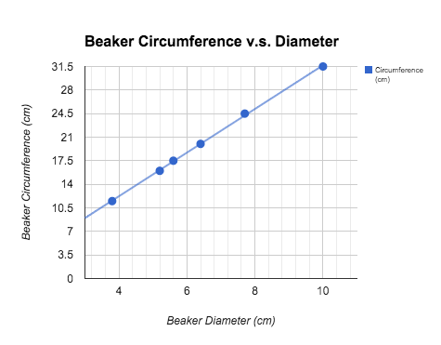

**Equation 1:** Demonstrates the slope of the line

$slope = \frac{ΔCircumference}{ΔDiameter}=\frac{31.5-11.5}{10-3.8}=\frac{20}{6.2}=3.3$

**Question:**

The numeric slope signifies the increase of the circumference of beakers as they increase in diameter. The slope value is to be expected because circumference increases at a faster rate than the diameter, and therefore the slope is positive and greater than 1.

Illinois Institute of Technology Markiyan Varhola

CHEM-124-L07 LAB CWID: 20324717

September 19, 2014

Paper Chromatography Pre-Lab

1. They will be the same, because the dye will travel the same distance up the strip of paper regardless of its length.
2. They will be different if the distances that the solvent fronts travelled are not the same, as the distance travelled by the solvent is accounted for in the equation that determines the Rf factor.
3. The Rf values will be different as the dyes might have different areas in which they are at the stationary phase, and this distance is accounted for in the equation.